**PIPE AND REDIRECTION OPERATIONS**

**1. Create a script named “myscript” in current directory to do the following.**

**a) create a dir named “subd1” in current directory**

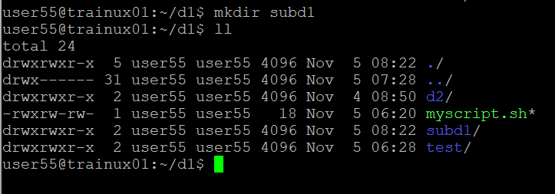

**b) create a file named “dircontent” with contents of the current directory**

**A:Command used---ls -1 > dircontent.c (>---refers to redirection)**

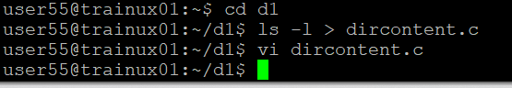

**c) display the contents of the file “dircontent”**

**A:Command used---cat dircontent.c**

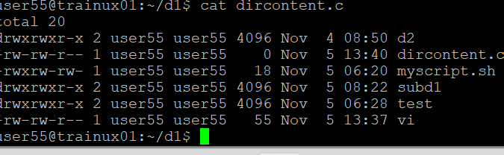

**d) display the contents of a non existing file named “unknownfile”**

**2. Run the script and validate the output in following cases**

**a) Redirect only the stdout to an o/p file named stdout.txt**

**A: Command**---$./myscript.sh > stdout.txt

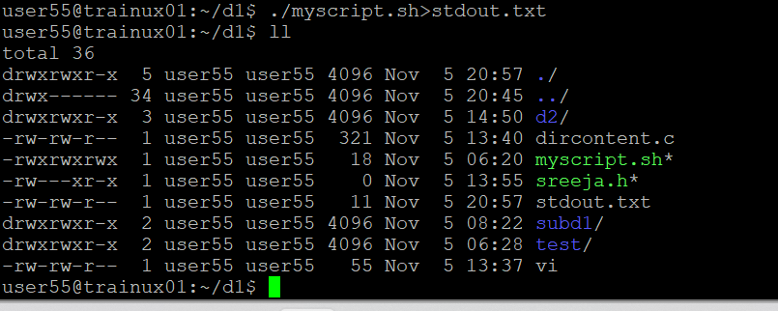

**b) Redirect only the stderr to an o/p file named stderr.txt**

**A: Command----**$./myscript.sh 2> stderr.txt

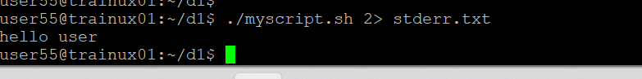

**c) Redirect both stdout and stderr to an o/p file named stdall.txtLL**

**A:Command**---$./myscript.sh & > stdall.txt

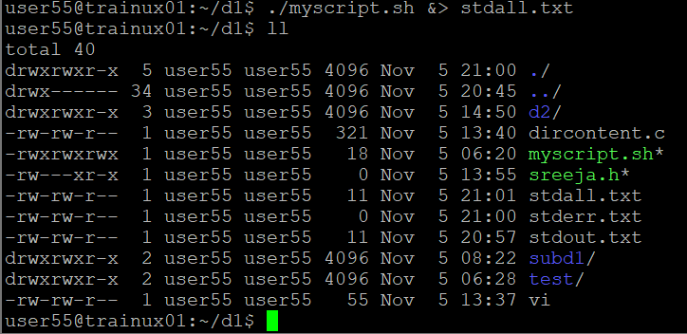

**d) Display all o/p and error and also redirect both stdout and stderr to an o/p file named stdall.txt**

**A: Command**----$./myscript.sh |& tee stall.txt

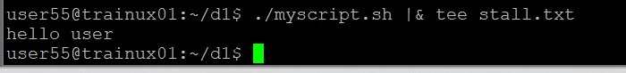

**3. Redirect the output of command below using pipe (|) to wc and get the output .**

**A: Command**----$ls -1 | wc

